Product | : | Temperature: | Working pressure (bar): | ☐ATEX  ☐NO ATEX

Size | ☐2” | ☐3” | ☐4” | ☐5” | ☐6”

Material | ☐Stainless Steel
 | ☐Carbon Steel
 | ☐CS + Aluminium
 | ☐PTFE
Balance system | ☐Torsion
 | ☐Linear
☐Pneumatic / ☐Hydraulic
☐ 2 Botton
☐ 3 Bottons
☐ Joystick

 | ☐Conterweight

Inlet | ☐Din
 | ☐ANSI 150lbs
 | ☐ANSI 300lbs
 | ☐
Hand | ☐ Righ hand
 | ☐ Left hand

Type | ☐A | ☐B | ☐C | ☐G | ☐H | ☐M
 | 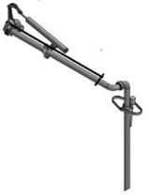 | 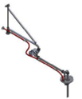 | 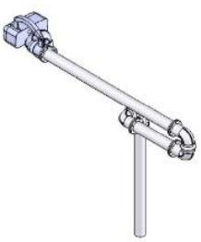 | 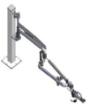 | 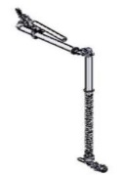 | 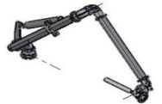

Dimensions | A: | B: | C:

Swivel Joints | Initial:
 | Middle:
 | End:
Suport | ☐ Pedestal support
☐ Mounting Plate
☐ Banner Support (☐Abajo ☐Encima)

☐ Brace Support (☐Abajo ☐Encima)
☐ Stabilizer

Ending connection | ☐ Din Flange (☐Swivel?)
☐ Brida ANSI 150 (☐Swivel?)
☐ Brida ANSI 300 (☐Swivel?)

☐ Camlock
☐ Api Coupler 4”
☐ CPP Vapor
☐ Male
☐ Hose unit
☐ Drop pipe 45º

☐ Deflector
☐ Breakaway

Overfill system | ☐ NO | ☐ YES
 |  | ☐Spider
 |  | ☐Cone
 |  | ☐Pneumatic sensor
 |  | ☐Electric Sensor
☐Drip pan
☐Coated Cone(☐ EPDM ☐ Viton ☐ PTFE)
☐Electric instalaton
☐ Cable
☐ Juction Box
☐ Amplifier

Vapor recovery | ☐ NO | ☐ YES
 |  | ☐Plate
 |  | ☐Cone
 |  | ☐Others
☐Vapor Rec. Hose
☐ Gassoflex
☐ Metal SS
☐ Otras
Heating | ☐ NO | ☐ Yes
☐Electrical heating
☐Jacketed
☐Thermal insualtion (rock Wool)
☐ Only Pipes
☐Pipes and elbows
☐ Pipes, elbows and swivel joints

Sensors | ☐Parking sensor
☐Right/Left Sensor position
☐Up/down sensor position
☐Cone sensor position
☐Other
Parking | ☐Lockdown
 | ☐Post. Liquid
☐Post. Gas
☐other

Valves | ☐Product Valve (☐ 1r arm ☐ 2nd arm / ☐3rd arm)
☒ Alum Hold Open
☐ Alum Stay Open
☐ Ball Valve
☐ Other

☐Vacuum Valve

 | ☐Drain Valve

Measurements ( mandatory in red )

R | mm
N | mm
M | mm
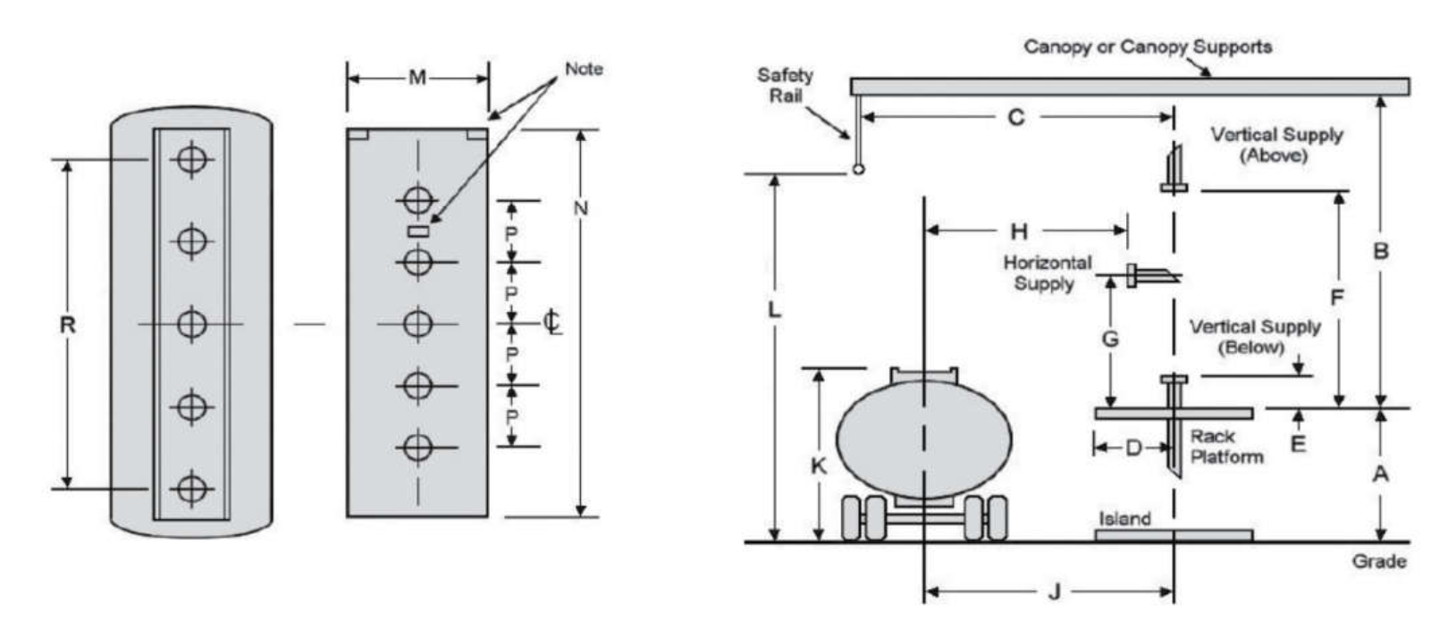
K | mm
J | mm
A | mm
F | mm
L
D
G
B
C
H
E

Documents, Certifications, Test, Inspections, etc

FAT ( Factory Acceptance Test) | ☐
Welding procedure and certification | ☐
X-Ray | ☐( %)
Material Certificate | ☐
Atex Certificate ( Ex Zone) | ☐
PMI (positive identification of the material) | ☐
ITP ( Inspection test plan) | ☐
Third Party Inspection | ☐
Paint certificate | ☐

